BUSINESS INSIGHT REPORT
Global Sales & Financial Performance
Dataset Name
GLOBAL SALES & FINANCIAL PERFORMANCE
Prepared by
MANOJ KUMAR K

2. Introduction
This report presents a structured analysis of the Global Sales & Financial Performance dataset, visualised through an Interactive Sales Dashboard built in Power BI. The purpose of this report is to translate the dashboard's visual outputs into clear, actionable business insight — examining overall sales and profitability performance, evaluating how individual product categories, months, regions and employees contribute to results, and identifying patterns that can inform decision-making. The analysis draws on Key Performance Indicators (KPIs), category-level and regional breakdowns, monthly trend data, and employee performance figures captured in the dashboard, and concludes with a set of business recommendations grounded in the findings.
The dataset spans the period from 2018 to 2024 and covers sales activity across six product categories, five geographic regions and multiple employees, with over 100,000 recorded orders. The insights that follow are intended to support planning around inventory, marketing, regional expansion, workforce performance, product portfolio, and customer targeting.

3. Dashboard Overview
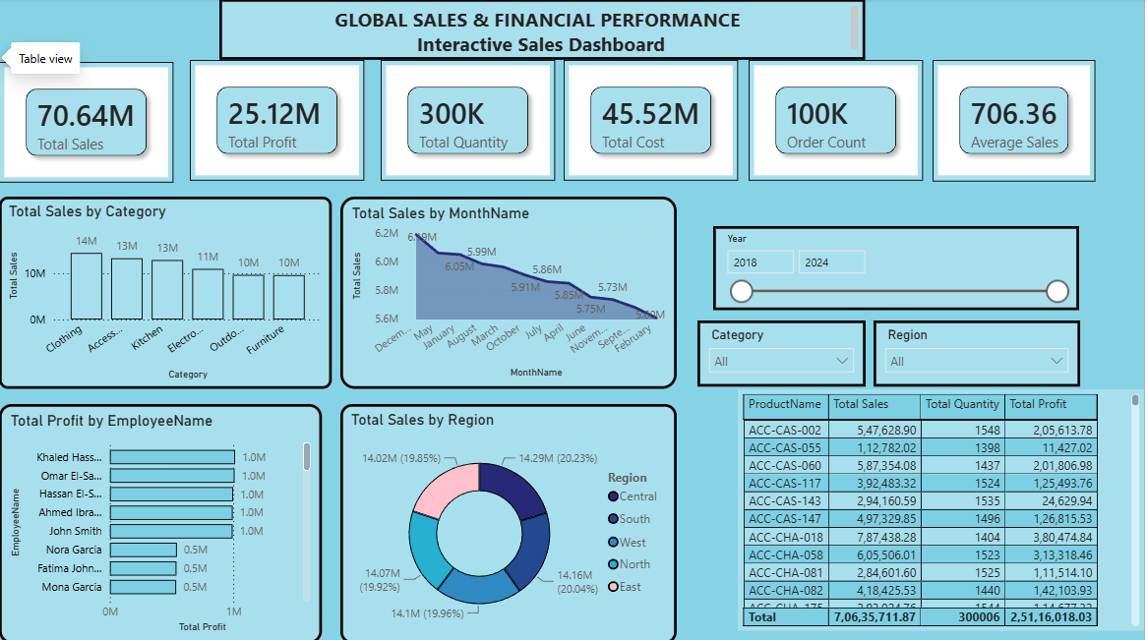

The dashboard consolidates the organisation's sales and financial performance into a single interactive view. Six summary cards at the top report the headline KPIs — Total Sales, Total Profit, Total Quantity, Total Cost, Order Count and Average Sales. Below these, visuals break performance down by Category, MonthName, EmployeeName and Region, alongside a filterable product-level detail table. Slicers for Year (2018–2024), Category and Region allow the report to be interrogated at different levels of granularity, making it possible to move from an enterprise-wide summary down to individual product, employee or regional performance in a few clicks.

4. KPI Analysis
The dashboard's summary cards give a snapshot of overall business scale and efficiency across the 2018–2024 period:
70.64M  Total Sales | 25.12M  Total Profit | 300K  Total Quantity
45.52M  Total Cost | 100K  Order Count | 706.36  Average Sales

Total Sales of 70.64M against a Total Cost of 45.52M yields a Total Profit of 25.12M, an overall profit margin of approximately 35.6%. With 300K units moved across roughly 100K orders, the average order carries about 3 units at an Average Sales value of 706.36 per order. This combination of a healthy margin and a high order count indicates a business operating at meaningful volume with solid, though not exceptional, unit economics — leaving room to improve profitability through cost control or premium product mix rather than through volume growth alone.

5. Product Category Performance Analysis

The "Total Sales by Category" chart ranks six product categories by sales value. Clothing leads with approximately 14M in sales, followed closely by Accessories and Kitchen at around 13M each. Electronics trails at roughly 11M, while Outdoor and Furniture form a lower tier at approximately 10M each.
Category | Approx. Total Sales | Relative Rank
Clothing | ~14M | 1st
Accessories | ~13M | 2nd
Kitchen | ~13M | 3rd
Electronics | ~11M | 4th
Outdoor | ~10M | 5th
Furniture | ~10M | 6th

The spread between the top category (Clothing) and the lowest (Furniture) is relatively narrow — roughly 4M — indicating a well-diversified portfolio rather than dependence on a single category. Clothing, Accessories and Kitchen together form the core revenue base, while Outdoor and Furniture, despite trailing, still contribute a substantial and fairly consistent share of sales, suggesting steady rather than weak demand.

6. Monthly Sales Trend Analysis
The "Total Sales by MonthName" line chart tracks monthly sales and shows a gradual downward trend across the year. Sales open strongest in December and January (around 6.05M–6.19M), remain elevated through May and August (close to 6.0M), and then taper progressively through March, October, July and April (roughly 5.85M–5.91M) before reaching their lowest points in June, November, September and February (approximately 5.6M–5.75M).
This pattern points to a seasonal peak around the year-end and early-year period, likely linked to holiday and New Year buying, with demand softening through the middle and later parts of the cycle. The decline is gradual rather than sharp, which suggests a natural seasonal easing rather than a structural loss of demand — but it also signals an opportunity to smooth revenue across the year through targeted promotions in the historically weaker months.

7. Regional Sales Analysis
The "Total Sales by Region" donut chart shows an unusually even distribution of sales across the five regions: South leads narrowly at 14.29M (20.23%), followed by East at 14.16M (20.04%), North at 14.1M (19.96%), West at 14.07M (19.92%) and Central at 14.02M (19.85%).
Region | Total Sales | Share of Total
South | 14.29M | 20.23%
East | 14.16M | 20.04%
North | 14.1M | 19.96%
West | 14.07M | 19.92%
Central | 14.02M | 19.85%

With less than half a percentage point separating the highest and lowest performing regions, sales are essentially balanced across all five territories. This even spread suggests a mature, well-established distribution footprint with no single region either significantly underperforming or carrying a disproportionate share of the business — reducing geographic concentration risk but also meaning regional growth will likely require targeted, region-specific initiatives rather than broad reallocation of resources.

8. Employee Performance Analysis
The "Total Profit by EmployeeName" bar chart shows a clear two-tier pattern. A top group — Khaled Hassan, Omar El-Sayed, Hassan El-Sayed, Ahmed Ibrahim and John Smith — each generate approximately 1.0M in profit. A second group — Nora Garcia, Fatima John and Mona Garcia — each generate approximately 0.5M, roughly half the profit of the top performers.

The consistency within each tier (near-identical values among the top five, and among the bottom three) suggests the gap reflects a structural factor — such as tenure, territory assignment, full-time versus part-time status, or account allocation — rather than random performance variance. This makes the gap a useful starting point for investigation: if it stems from unequal opportunity (e.g. account or territory size), it points to a resourcing fix; if it reflects a genuine skills or productivity gap, it points to a coaching and training need.

9. Business Recommendations
Based on the KPI, category, seasonal, regional and employee performance findings above, the following actions are recommended:

Inventory Planning
- Align stock levels ahead of the December–January and May–August peaks for Clothing, Accessories and Kitchen, and plan modest drawdowns heading into the June, September and November troughs to reduce holding costs.
- Right-size safety stock for Outdoor and Furniture, which move at a steadier but lower volume, to avoid overstock given their comparatively smaller share of sales.

Marketing Strategy
- Launch targeted promotions in the historically weaker months (February, June, September, November) to flatten the seasonal dip identified in the trend analysis.
- Concentrate premium campaign spend on Clothing, Accessories and Kitchen while running lighter, cost-efficient campaigns for Outdoor and Furniture to lift their share.

Regional Expansion
- Given that regional sales are near-identical; rather than shifting investment between regions, pursue targeted local initiatives (localised promotions, region-specific product assortments) in each of the five regions to grow the whole base.
- Consider using South and East (currently marginally ahead) as pilot markets for new product lines or store formats before wider rollout.

Employee Performance
- Investigate why Nora Garcia, Fatima John and Mona Garcia generate roughly half the profit of the top five — checking account size, territory, tenure and working hours before concluding it is a skills gap.
- Introduce structured coaching, mentoring or account reallocation for the lower-tier group, using the top five performers' approach as a benchmark.

Product Portfolio
- Maintain the current six-category mix, as no category is a significant underperformer; instead of cutting lines, focus on improving margin within Outdoor and Furniture.
- Explore bundling slower categories (Outdoor, Furniture) with top sellers (Clothing, Accessories) to lift their attachment rate.

Customer Targeting
- Segment customers using order-level data (average order value of 706.36 across ~3 units) to identify and target higher-basket-size customers with cross-sell offers.
- Use loyalty or repeat-purchase incentives timed to the pre-peak months (October–November, March–April) to pull forward demand into stronger sales periods.

